**DELA FUENTE, MARIANNE M.**

**2ECE-D**

**PROBLEM 1**

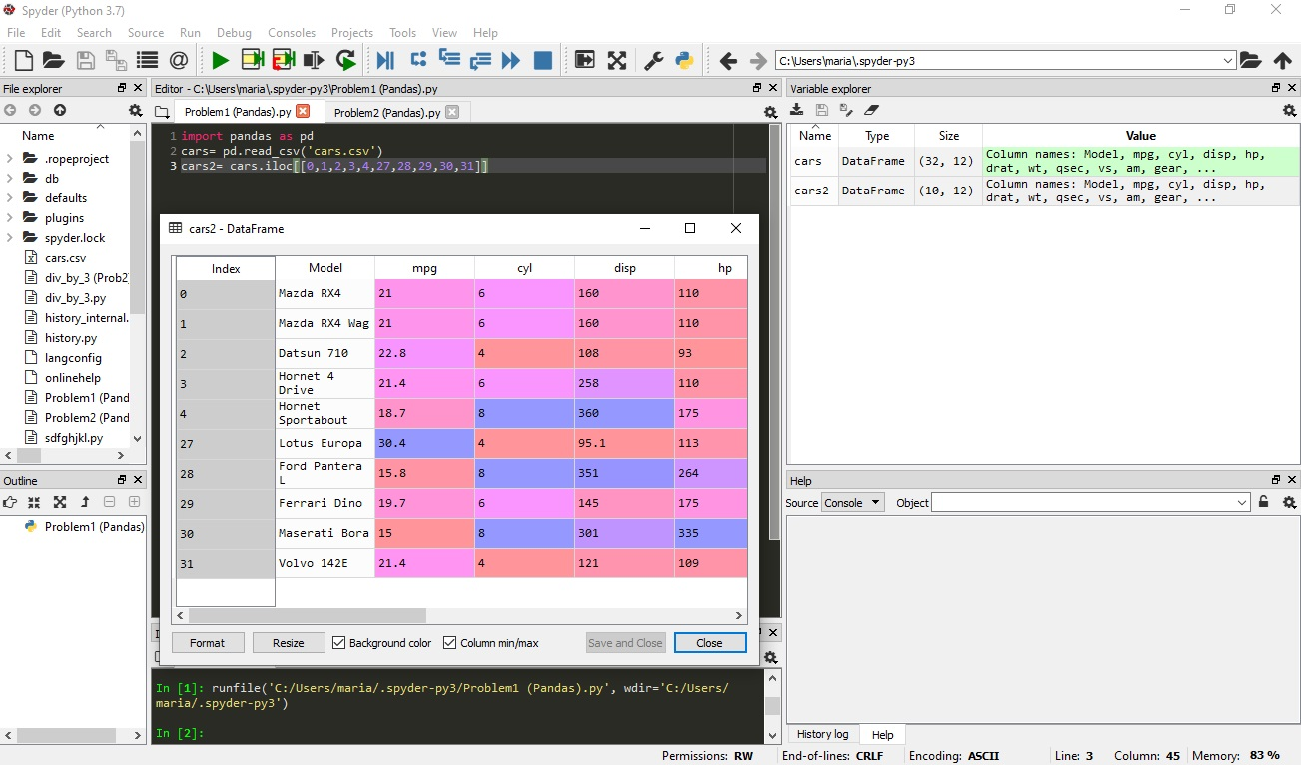

**PROBLEM 2A**

**(Including Index and Model column)**

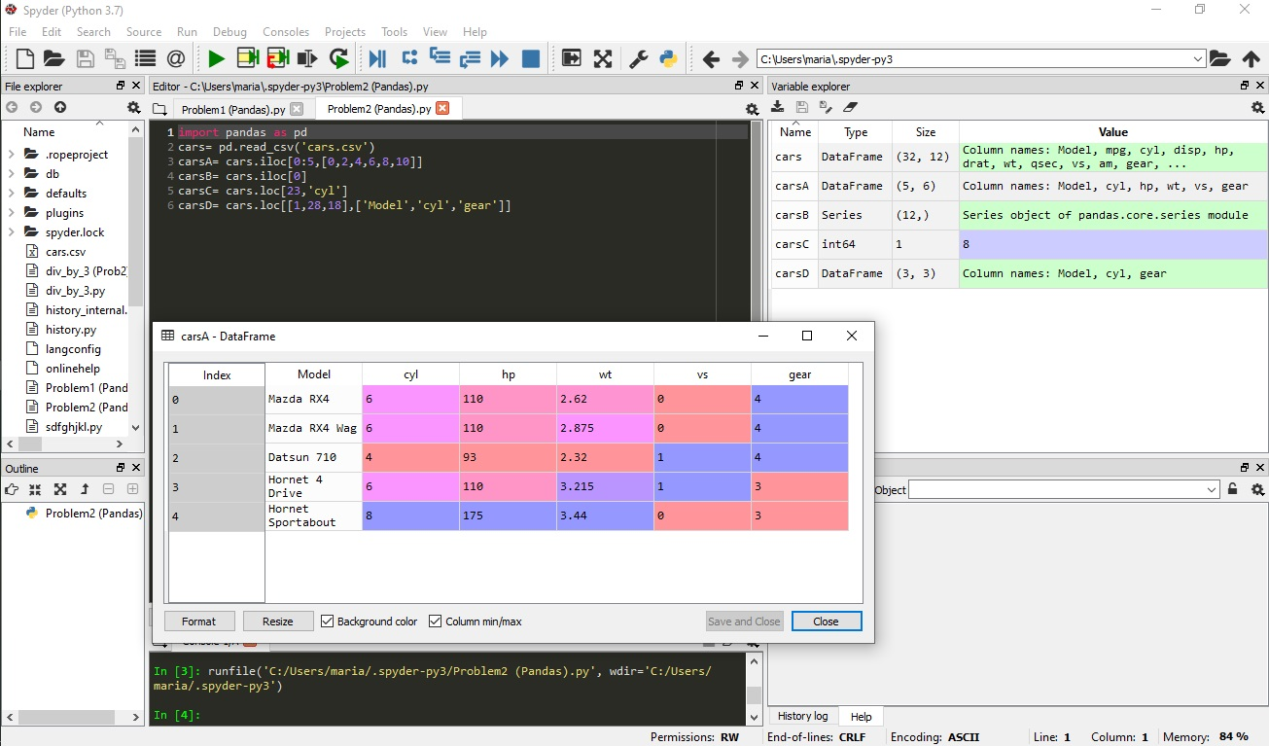

**(Including Model column only)**

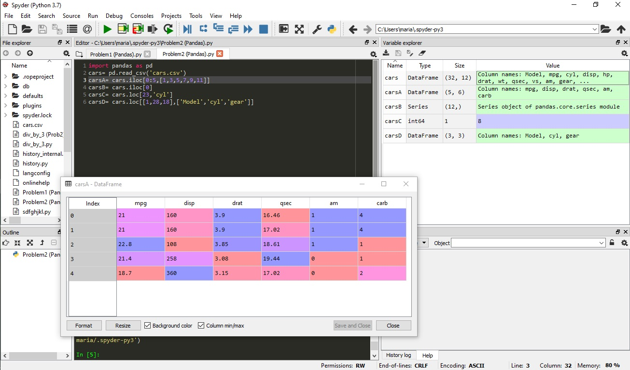

**PROBLEM 2B**

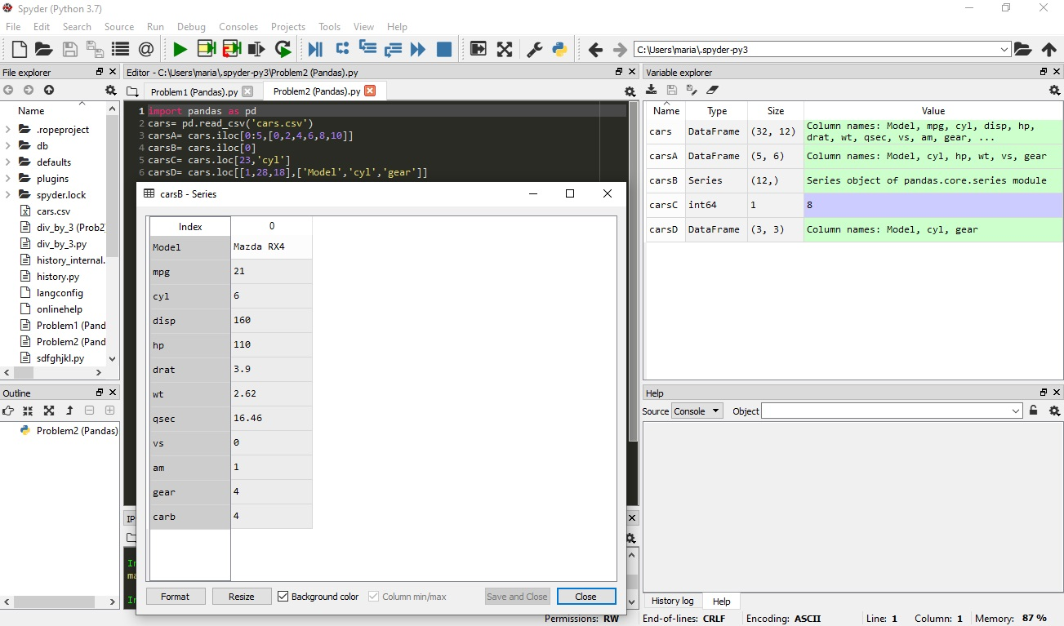

**PROBLEM 2C**

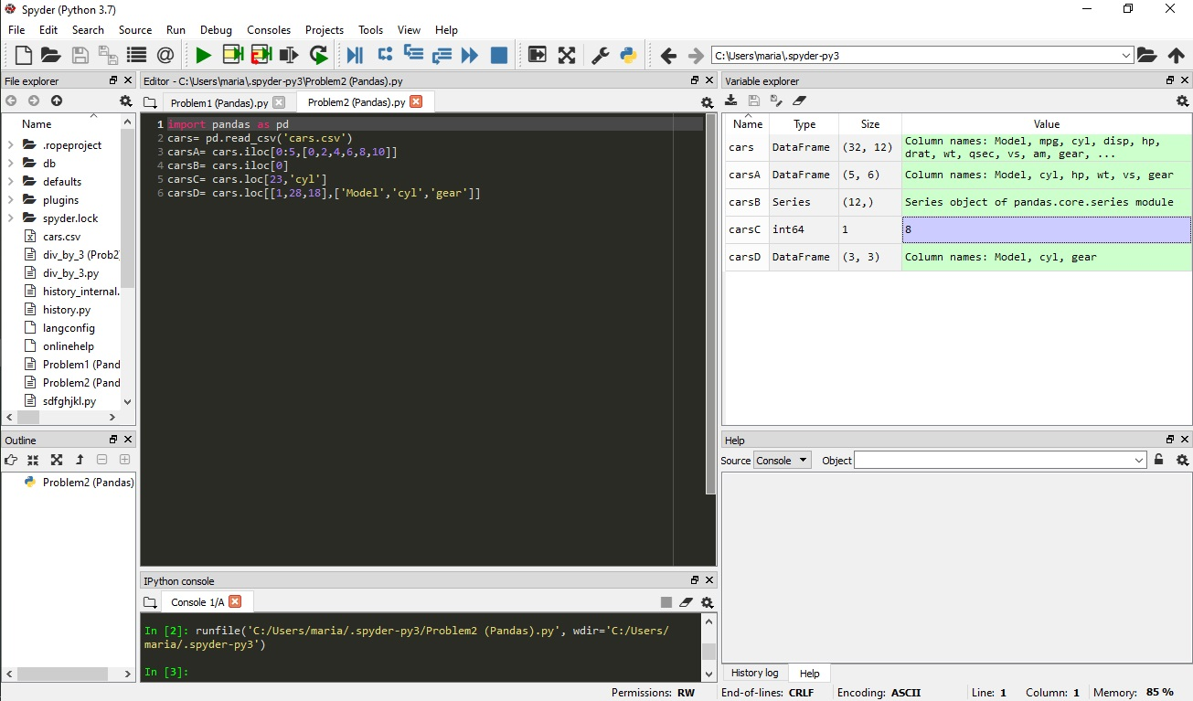

**8**

**PROBLEM 2D**



